22.56: a) We could place two charges 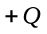on either side of the charge 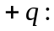

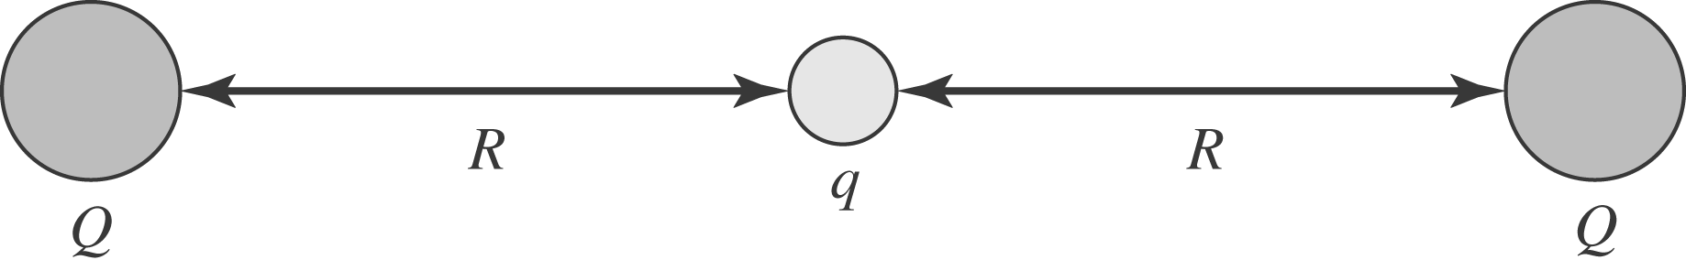

b) In order for the charge to be stable, the electric field in a neighborhood around it must always point back to the equilibrium position.
c) If is moved to infinity and we require there to be an electric field always pointing in to the region where had been, we could draw a small Gaussian surface there. We would find that we need a negative flux into the surface. That is, there has to be a negative charge in that region. However, there is none, and so we cannot get such a stable equilibrium.
d) For a negative charge to be in stable equilibrium, we need the electric field to always point away from the charge position. The argument in (c) carries through again, this time inferring that a positive charge must be in the space where the negative charge was if stable equilibrium is to be attained.

